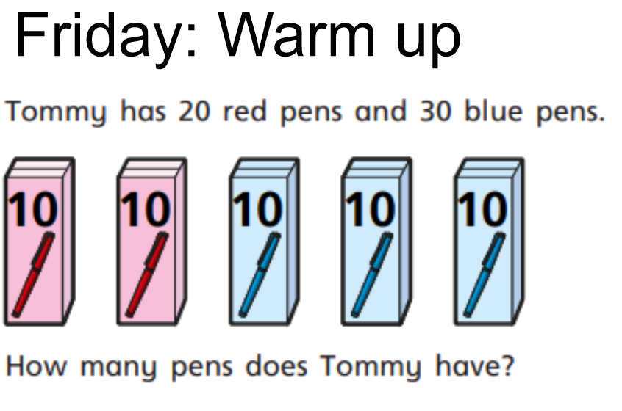

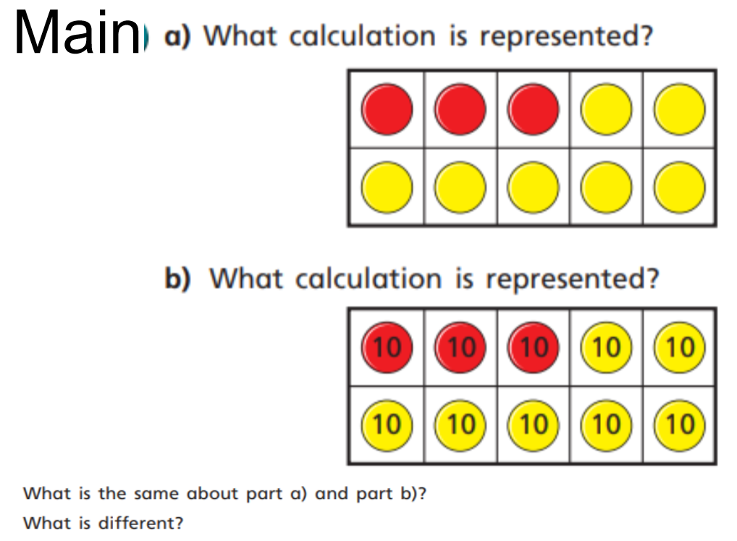

Activity : Write down six bonds to 10 (4+6=10, 7+3=10). Then ask them to use this to write six bonds to 100 (40+60=100, 70+30=100).

