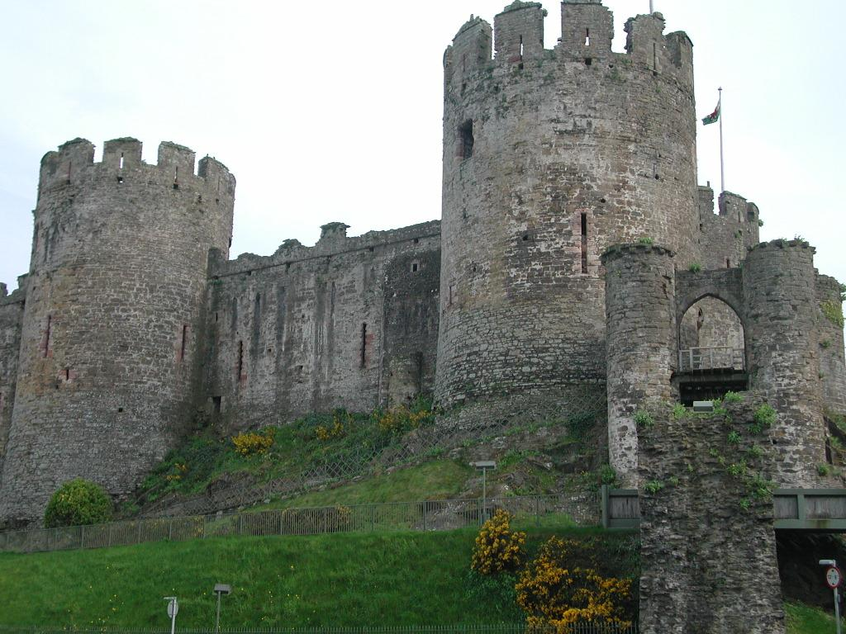

Conwy Residential Visit
15th – 17th Sept 2021

Dear Parent / Carer

Due to the success of previous visits to Conwy, we are planning to run the same trip again for children in year 5.
Currently overnight trips for all schools have been cancelled until December 2020, once guidance on school trips for 2021 has been released we will share this information with you.

The details are as follows:

- The YHA Youth Hostel is situated in the centre of Conwy and provides comfortable hotel style accommodation. There are also showers, drying rooms, lounge areas, first aid room, kitchens, laundry, classroom, dining hall etc.

- The sleeping accommodation will be in small comfortable rooms of 2/3 and 4/5 children. All rooms have their own washing facilities, bunk beds and storage for the children’s clothes and belongings. The staff will be accommodated with the children in separate rooms.

- All meals, snacks, and drinks are provided (full breakfast, packed lunch and three course dinner).

- The activities we intend to provide will include walking, beach study, crafts, games and social interaction. We also intend to visit Conwy Castle and Llandudno. In addition, the children will be provided with opportunities to promote their social, moral and cultural development and give them an “experience” of life whilst having fun!

- Children will be looked after by school staff, they are likely to include Mrs Jones, Miss Amos and Mrs Nesbit.

- The cost will be approximately £200 (a reduced cost may apply to those children who are entitled to income-based pupil premium) and will include all the food (except a packed lunch on the first day), transport, bed linen and all the activities.

- We are not asking for deposits yet, but so we can gauge how many children may want to take part in this trip please can we ask that you email jcheetham@ivybank.cheshire.sch.uk with the following information:-

Childs name
Class teacher
Yes, I would like my child to take part in the proposed Conwy trip
No, I do not want my child to take part in the proposed Conwy trip

Yours sincerely
Mrs Gill.

