Name
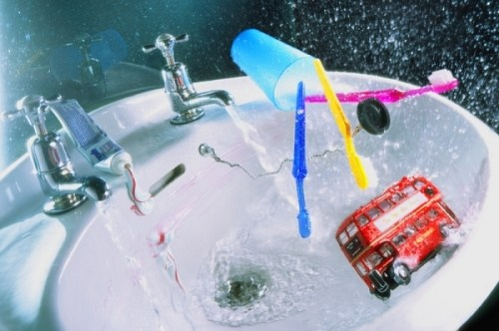
The Naughty Bus Superwrite

