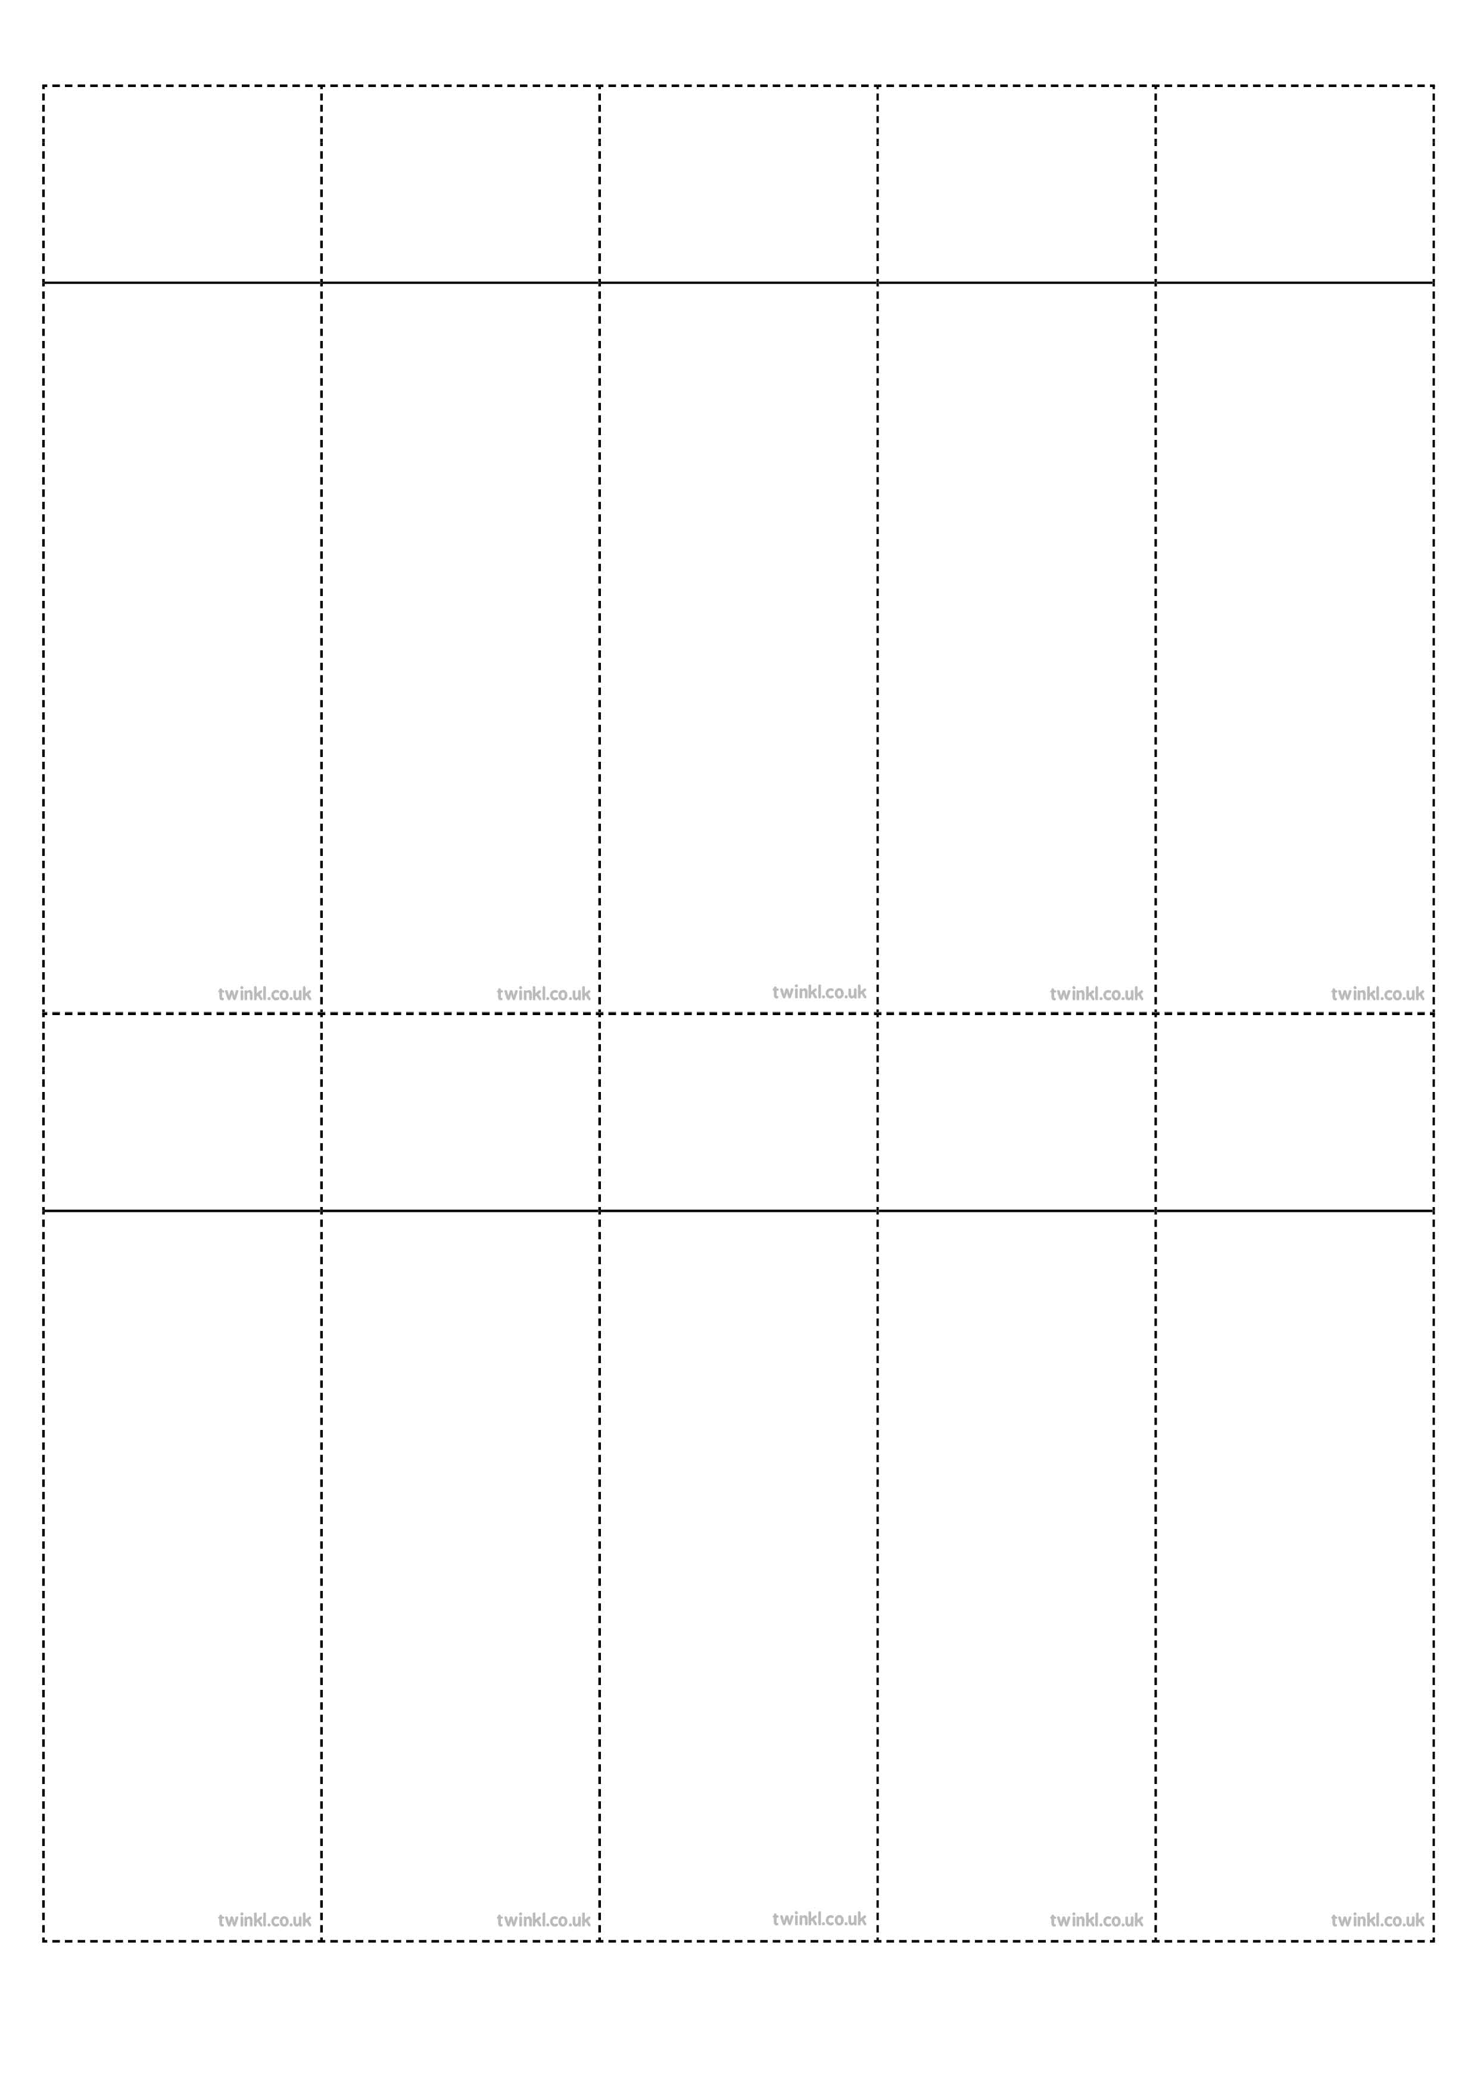
Week 1
Words with the /s/ sound spelt with ‘sc’
science
crescent
discipline
fascinate
scent
scissors
ascent
descent
scientist
scenery
Week 1
Words with the /s/ sound spelt with ‘sc’
science
crescent
discipline
fascinate
scent
scissors
ascent
descent
scientist
scenery
Week 1
Words with the /s/ sound spelt with ‘sc’
science
crescent
discipline
fascinate
scent
scissors
ascent
descent
scientist
scenery
Week 1
Words with the /s/ sound spelt with ‘sc’
science
crescent
discipline
fascinate
scent
scissors
ascent
descent
scientist
scenery
Week 1
Words with the /s/ sound spelt with ‘sc’
science
crescent
discipline
fascinate
scent
scissors
ascent
descent
scientist
scenery
Week 1
Words with the /s/ sound spelt with ‘sc’
science
crescent
discipline
fascinate
scent
scissors
ascent
descent
scientist
scenery
Week 1
Words with the /s/ sound spelt with ‘sc’
science
crescent
discipline
fascinate
scent
scissors
ascent
descent
scientist
scenery
Week 1
Words with the /s/ sound spelt with ‘sc’
science
crescent
discipline
fascinate
scent
scissors
ascent
descent
scientist
scenery
Week 1
Words with the /s/ sound spelt with ‘sc’
science
crescent
discipline
fascinate
scent
scissors
ascent
descent
scientist
scenery
Week 1
Words with the /s/ sound spelt with ‘sc’
science
crescent
discipline
fascinate
scent
scissors
ascent
descent
scientist
scenery

