Spelling at Ivy Bank
‘Of course words are magic! That’s why they call it spelling.’
- Brian Holguin

We are teaching spelling as a problem-solving process; a mission to remember spellings for life. The purpose and function of this task is for the children to see how words can be linked when they have the same sound and spelling.

For two weeks prior to this becoming an activity for the children, the teacher will spend time introducing fifteen words, which will be the vehicle to demonstrate sound and spelling patterns.
If I can spell ‘know’, I can also spell… knit, knight, knowledge etc.
If I can spell ‘meet’, I can also spell… sleet, sleep, creep, feet etc.

To aid transition to long term memory, your child will take part in a spelling quiz on a Friday (once a fortnight).

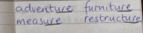
For each spelling list, your child will have explored these in class and identified the tricky parts within each word. In addition to this, they have successfully recognised the tricky part in other common words:

This is your child’s journal, where they can use the double page spread that the list is stuck on to explore their spelling words, by identifying the tricky parts and recalling other words that have the same phoneme focus. They will complete the quiz at the back of it.
Please encourage your child to be ‘brave spellers’ and it is okay if they make mistakes. Use this as a way they can improve, with practice, and commit correct spellings to their long-term memory.

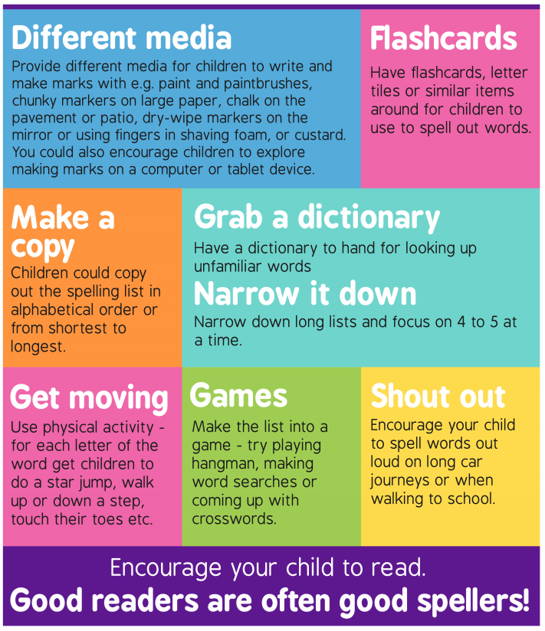
Below, there are some multi-sensory ways, which your child can try, so the vocabulary and their spellings become ‘stuck’ in their knowledge:

