Can you read the sentences and match them to the pictures?

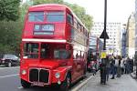

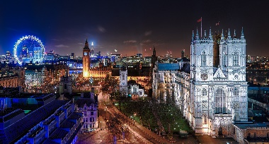

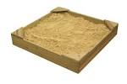

Naughty Bus Sentences

I am a London Bus.
I went to London.
I squashed the orange.
I hid in the sandpit.

