How to wash a Naughty Bus
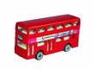
You will need:
sponge
soap
towel

_1._____________________________________________________________________2._____________________________________________________________________3.____________________________________________________________________

