How to wash a Naughty Bus
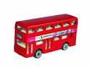
You will need:
______________
______________
______________
______________

__1._____________________________________________________________________2._____________________________________________________________________3._____________________________________________________________________4.___________________________________________________________________

